Unit 2 – Worksheet 4

**Two Bicycles**

Adapted from AMTA 2006

1. 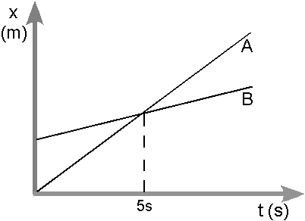Consider the position vs. time graph below for cyclists A and B.
2. Do the cyclists start at the same point? How do you know? If not, which is ahead?
3. At t= 7s, which cyclist is ahead? How do you know?
4. Which cyclist is travelling faster at t = 3s? How do you know?
5. Are their velocities equal at any time? How do you know?
6. What is happening at the intersection of lines A and B?
7. Consider the new position vs. time graph below for cyclists A and B.

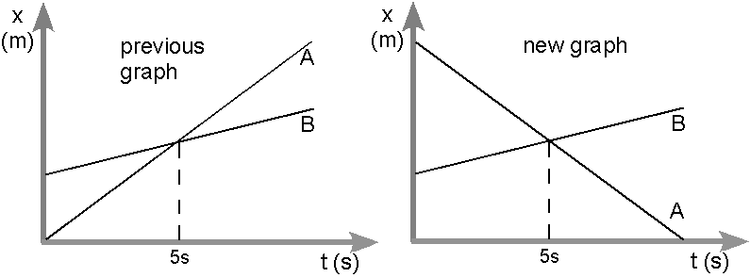

1. How does the motion of the cyclist A in the new graph compare to that of A in the previous graph from page one?
2. How does the motion of cyclist B in the new graph compare to that of B in the previous graph?
3. Which cyclist has the greater speed? How do you know?
4. Describe what is happening at the intersection of lines A and B.
5. Which cyclist traveled a greater distance during the first 5 seconds? How do you know?